Assignment 2
Jackson Wiebe 3519635
Answer all questions – maximum 100 marks. You must score at least 50 to pass the assignment.
- (15 marks) Design an algorithm for the following operations for a binary tree BT, and show the worst-case running times for each implementation:
preorderNext(x): return the node visited after node x in a pre-order traversal of BT.
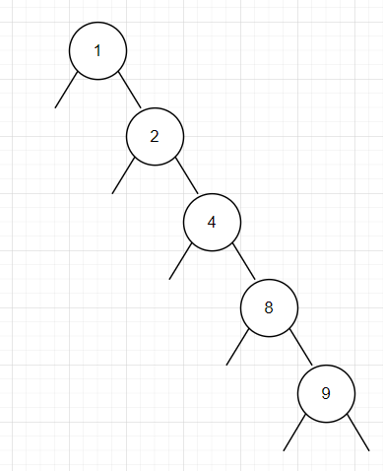
In my implementation, see Question1.Java and dependencies, we can see that the tree is built with the values 1,2,4,8,9. When the algorithm is asked to search for #9 with a pre-order traversal, it will be forced to look through every node to find the target which has been placed on the right child of each node. The worst case search time is O(n) elements.

postorderNext(x): return the node visited after node x in a post-order traversal of BT.
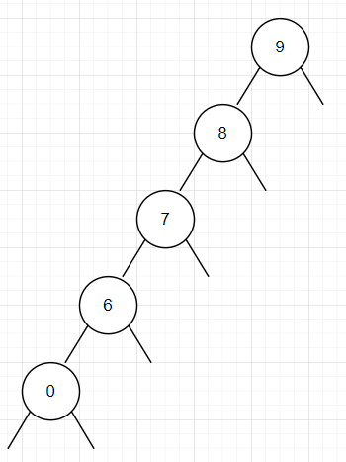
In my implementation, see Question1.Java and dependencies, we can see that the tree is built with the values 9,8,7,6,0. When the algorithm is asked to search for #0 with a post-order traversal, it will be forced to look through every node to find the target which has been placed on the left child of each node. The worst case search time is O(n) elements.

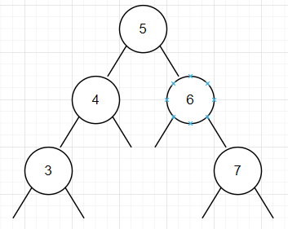
inorderNext(x): return the node visited after node x in an in-order traversal of BT.
In my implementation, see Question1.Java and dependencies, we can see that the tree is built with the values 5,4,6,3,7. When the algorithm is asked to search in-order traversal it will be forced to look through every node to find the target which has been placed at the root. The worst case search time is O(n) elements.

- (25 marks) Design a recursive linear-time algorithm that tests whether a binary tree satisfies the search tree order property at every node.
What we want to know is if the binary tree and every element inside it, are properly bound by the parent nodes above them. That is does each child node fit within the numerical bounds of the parents above it. To write this function I added some variables in my BinaryTree.java class that keeps track of the Min and Max value as its being placed in the tree. Then for verification all we need to do is search from the root using those bounds. We can call isValid() which will invoke the recursive helper function isValidRecursive(). The recursive function is initial feed with the root node, global min and max. Each subsequent run of the Recursive will seach each child with a narrowing set of min/max related to the parent node. Eventually reaching null nodes.
Item 0 must fit within the global min and max bounds.
The left child of item X must fit within the global min and its parent value. We can subtract 1 from the parent to ensure we only get unique values.
The right child of item X must fit within the global max and its parent value. We can add 1 to the parent to ensure we only get unique values.

- (20 marks) Exercise 8.2. Illustrate what happens when the sequence 1, 5, 2, 4, 3 is added to an empty ScapegoatTree, and show where the credits described in the proof of Lemma 8.3 go, and how they are used during this sequence of additions.
I started by building a Scapegoat tree which was quite difficult to understand. Many of the online tutorials do not have great comments however I do now understand how they are packing the tree into an array for later rebuilding. I then added the credit system described in Lemma 8.3., When a node is added to the tree we increment the int BTNode.scapeGoatCredits and when we do a rebuild, the node which we rebuilt around was decremented. Thus we should always see a positive credit score for our tree.
- (20 marks) Implement a commonly used hash table in a program that handles collision using linear probing. Using (K mod 13) as the hash function, store the following elements in the table: {1, 5, 21, 26, 39, 14, 15, 16, 17, 18, 19, 20, 111, 145, 146}.
See implementation in Question4.java.
I started by implementing the hashing function as input MOD 13. With this algorithm our maximum hash can never exceed range of 0-12 and such we can define the table size as 13 elements. The Add( int ) method was written to handle collisions with a linear probing technique. If the hashtable element was not free, we would try the index +1 until the whole hash table had been searched, at which point the new data is simply dropped.
The result for the target input is as such:
Numbers 1, 5, 2, 26 are added seamlessly to their respective hash slots of 1,5,8,0
Numbers 39, 14, 15, 16, 17, 18, 19, 20, 111 are added to the table however not in their intended slots but to slots further down the table.
Numbers 145 and 146 are dropped since the table is full by this point.
Overall 55 collisions.
- (20 marks) Exercise 6.7. Create a subclass of BinaryTree whose nodes have fields for storing preorder, post-order, and in-order numbers. Write methods preOrderNumber(), inOrderNumber(), and postOrderNumbers() that assign these numbers correctly. These methods should each run in O(n) time.
Please see Question5.java. For this question I started with my previous binaryTree.java and added variables to the node object representing the different search orders. As the algorithm recursively traverses the tree it will assign a number from a global variable. I also added a graphic printer to represent the tree. The demo data added I tried to represent all cases where the traversal methods could showcase the various effects of looking at the Root, Left, or Right node sequence.
I found this question quite difficult to understand. Perhaps more clarification could be added for future students. Discussion in unit 7 here: https://scis.lms.athabascau.ca/mod/forum/view.php?id=19164

